**Overview**

This document specifies how to use a Tableau workbook to quickly generate campaign metrics (CTR, CTR, #impressions) and graphs to help report generation. It allows to view performance by creative, line item, over time and day part.

The files can all be found in *Dropbox > Alphonso Campaign Reporting > Elle & Gaelle*

**Generate and import your Performance data to the Tableau Performance Report Workbook**

Log in to Beeswax

In the Reporting tab, go to the Query tool.

Fill in the following fields:

* Report type: Performance Report
* Fields:
  + Hour
  + Line item ID
  + Creative Name
* Metrics
  + Clicks
  + Impressions
  + Video Completes
* Select your campaign in Campaign Name or Campaign ID field
* Format: CSV
* Report name: Performance Report

Run and Download the report

**Rename it Performance Report.csv**

Place it in the Dropbox in the following location: *Alphonso Campaign Reporting > Elle & Gaelle* **(replace the previous file with the same name)**

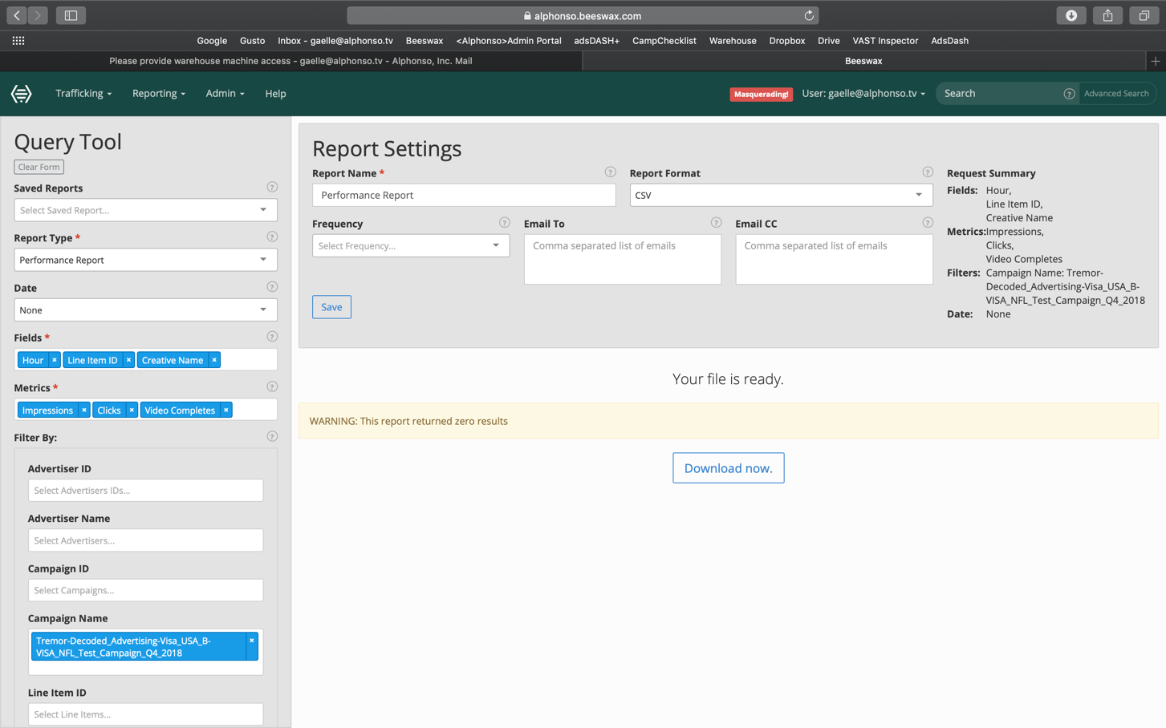

Figure 1 – Beeswax Query Tool Interface

Get the Performance Report Tableau WorkBook [here](PerformanceReportTableauWorkbook.twbx) (or from dropbox in *Alphonso Campaign Reporting > Elle & Gaelle*)

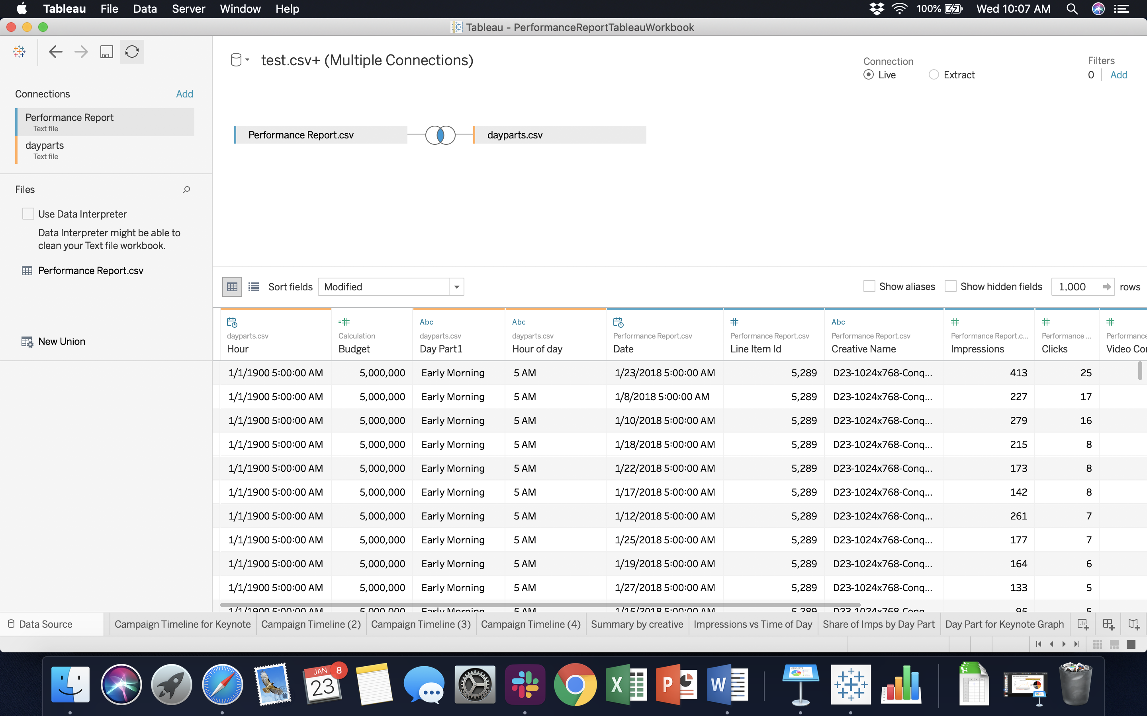Open the Tableau Workbook

Click on the tab Data Source (see screenshot below)

In the upper left corner, refresh the connections by clicking on

The data should refresh and correspond to the report you just generated. If that is not the case try the steps below.

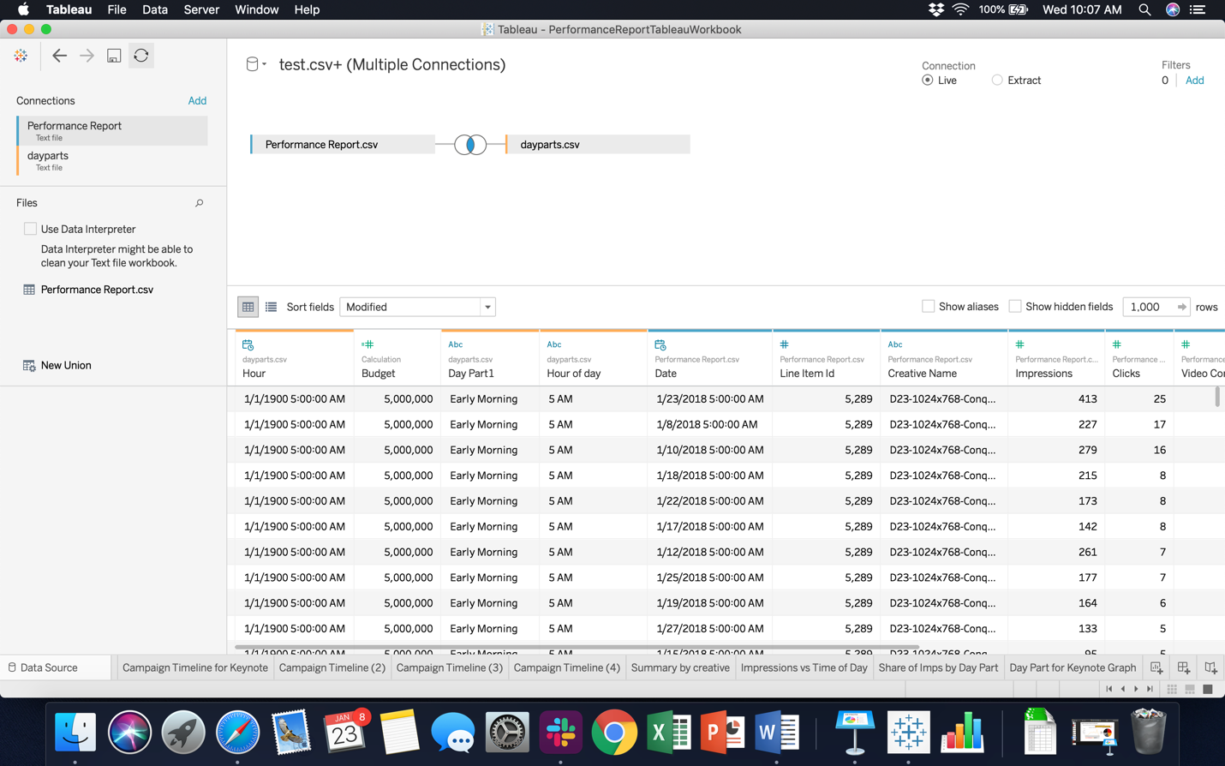

Figure 2 – Tableau Data Source Tab

**Refreshing the data source is not working?**

1. Make sure your DropBox is syncing
2. Wait a couple of minutes and try refreshing again
3. Make sure the csv file entitled Performance Report.csv in the Elle & Gaelle Folder is yours and try refreshing again
4. 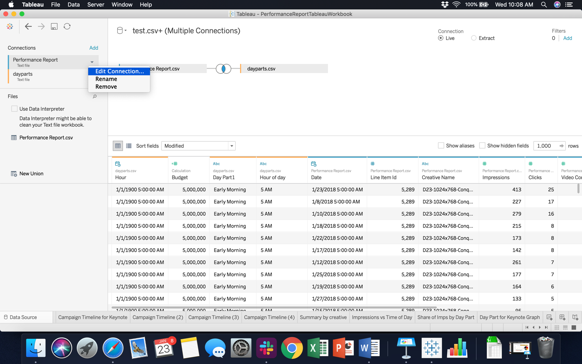In the “Data Source Tab”, click on Performance Report > Edit Connection, and find your Performance Report in the Dropbox.

Next, you need to update campaign budget, CTR benchmark and VCR benchmark. On the Data Source tab, find the column “Budget’, click on the downward arrow, then edit, type in your campaign budget (in impressions, from the deal sheet) and click OK. **Remember that for CPVC campaigns the budget in impressions is budget in video completes/0.8**

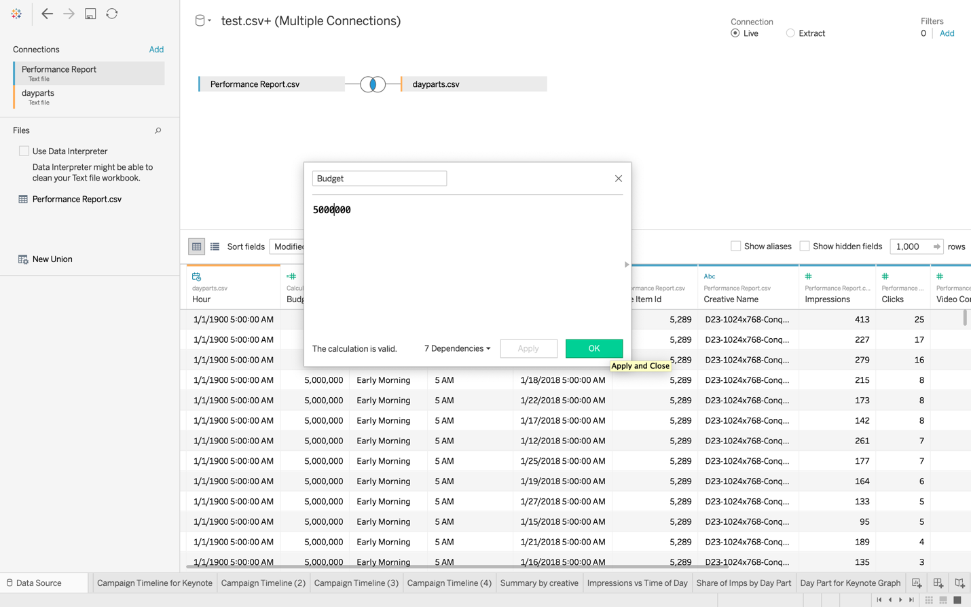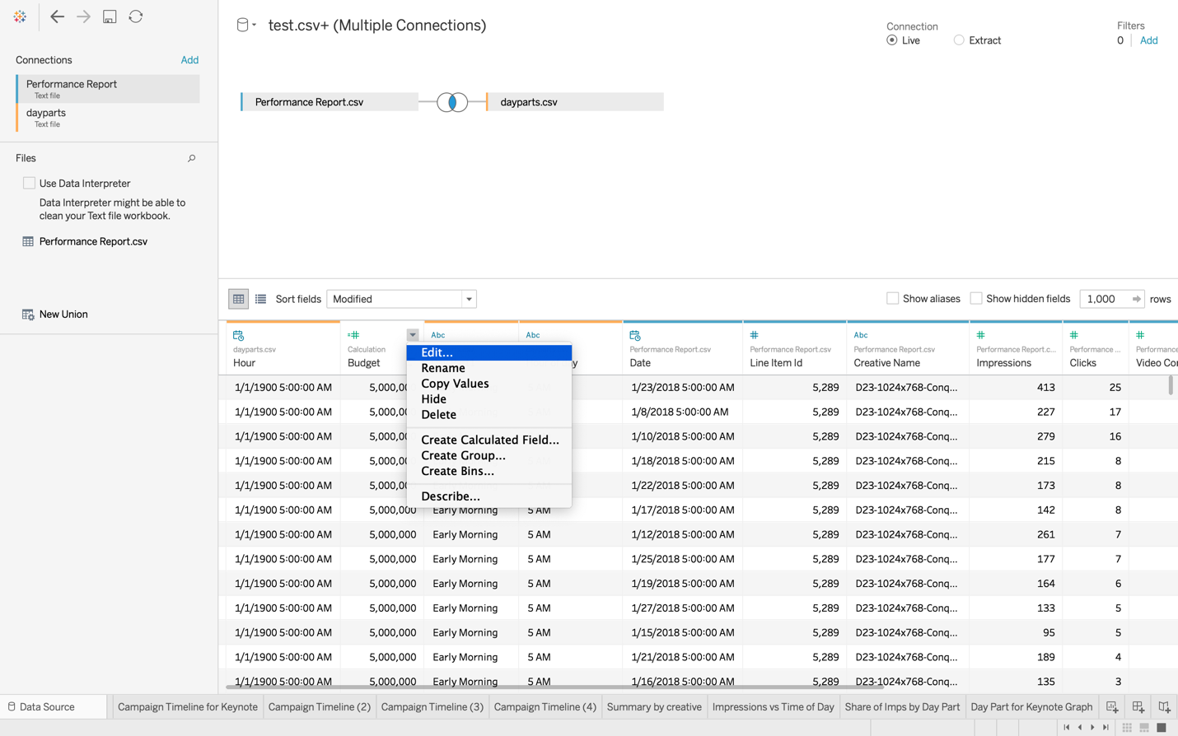

Do the same to update benchmark CTR and VCR if needed. Benchmark CTR is set to 1% and VCR to 85% for mobile/tablet campaigns, 75% for desktop campaigns.

You have now imported your report to the notebook and the graphs should correspond to your campaign. The different sheets in the Workbook are explained in the section “Navigating and using the workbook”.

**Navigating and using the workbook**

Before pulling data from the workbook, make sure you updated the budget, the benchmark vcr and the benchmark ctr in the Data Source tab.

**Worksheet 1: “Campaign Summary”**

Provides metrics over the whole campaign.

* Total Number of Impressions
* CTR (%)
* CTR (as a % of benchmark CTR)
* VCR (%)
* VCR (as a % of benchmark VCR)

These values are used to generate the summary slide in a Digital Campaign Performance Study.

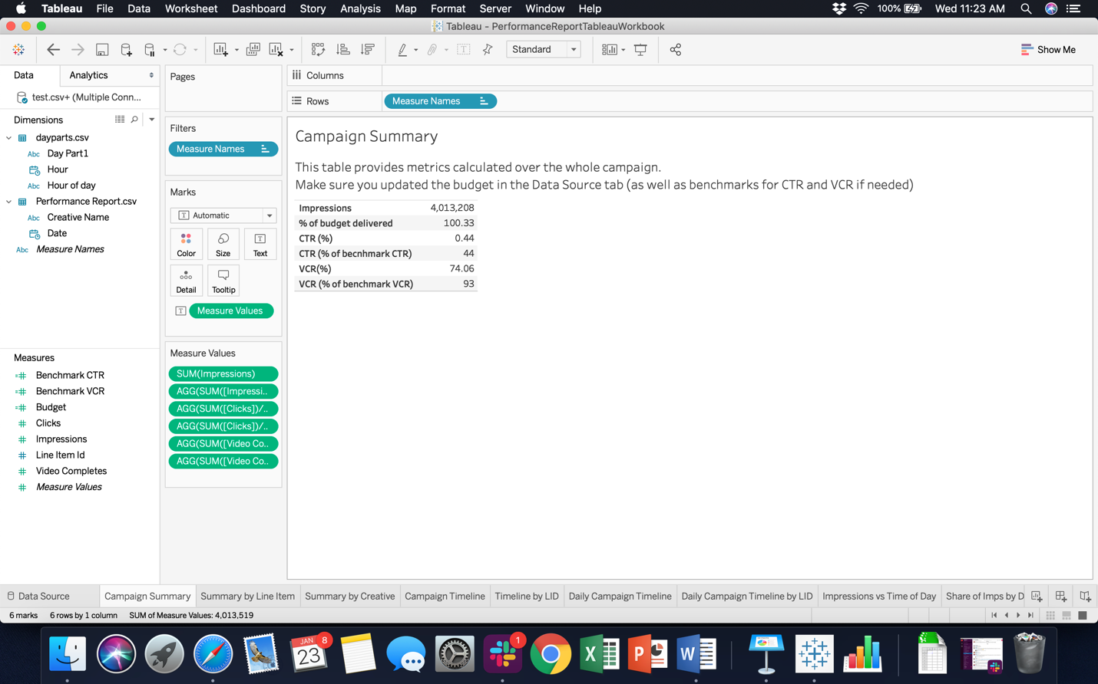

**Worksheet 2: “Summary by Line Item”**

Provides metrics (Impressions, CTR, VCR) broken down by Line Item or groups of line items.

You can use it to observe how different line items performed, and to generate the slide “Performance by Targeting Tactic” in a Digital Campaign Performance Study.

On the right pane of the worksheet, you can select which line items you want included in the table. For example if you want to calculate metrics for the “Conquering” targeting tactic, you would select all of the line items corresponding to this tactic and write down the corresponding metrics.

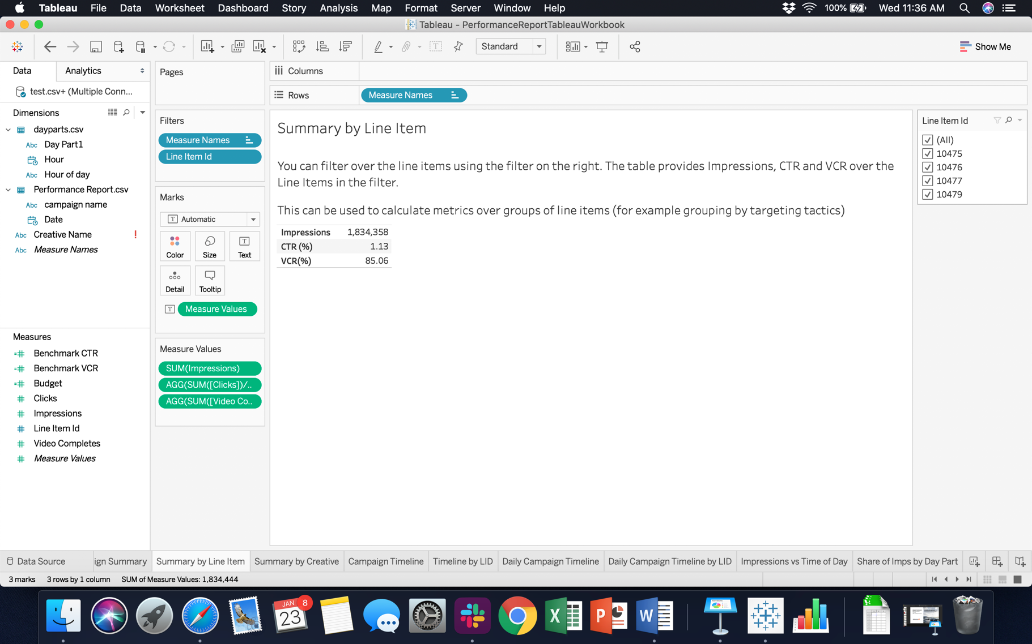

Filter over LID here

**Worksheet 3: “Summary by Creative”**

Provides metrics (Impressions, CTR, VCR) broken down by creative.

You can use it to observe how different line creatives performed, and to generate the slide “Performance Summary by Creative” in a Digital Campaign Performance Study.

**Worksheet 4: “Campaign Timeline”**

Plots the cumulative number of impressions (as % of budget delivered) over time.

The y axis is $\frac{Total Number of Impressions Delivered}{Budget}*100$.

Depending on the length of your campaign, you can adjust the X-axis by clicking on (+) and (-) in the columns line (to choose hour/day/month).

This graph can be used to generate the “Campaign Delivery Progress” slide in a report.

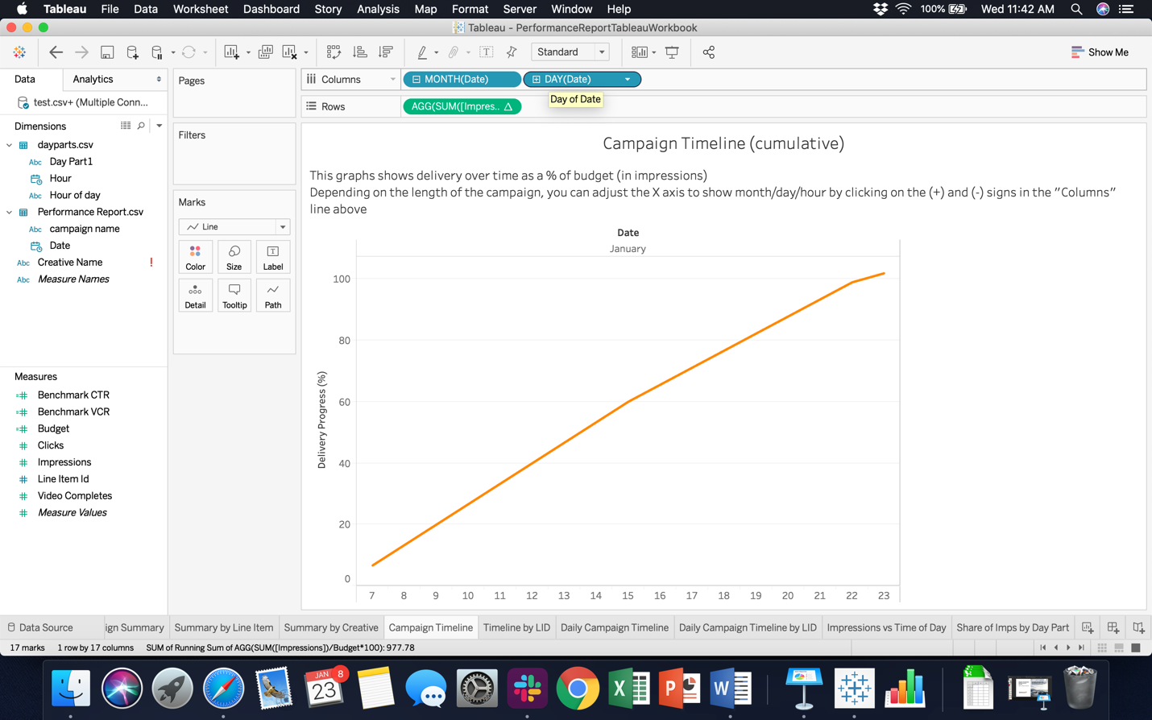

Adjust the X-axis here by clicking on (+) and (-)

You can copy the graph as an image by right clicking on it, then copy > image.

You can also copy the raw data by cright clicking, then copy > data. You can then go to the Keynote presentation, click Edit Chart Data and paste your data.

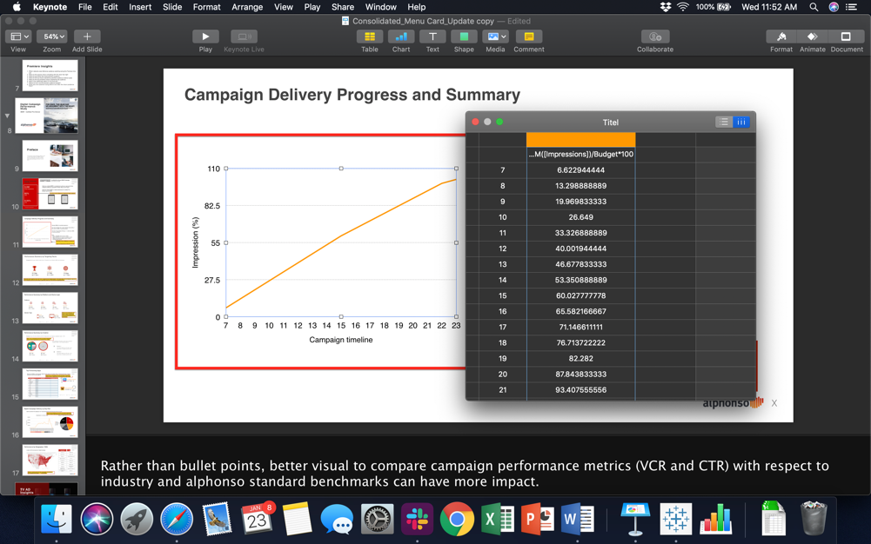

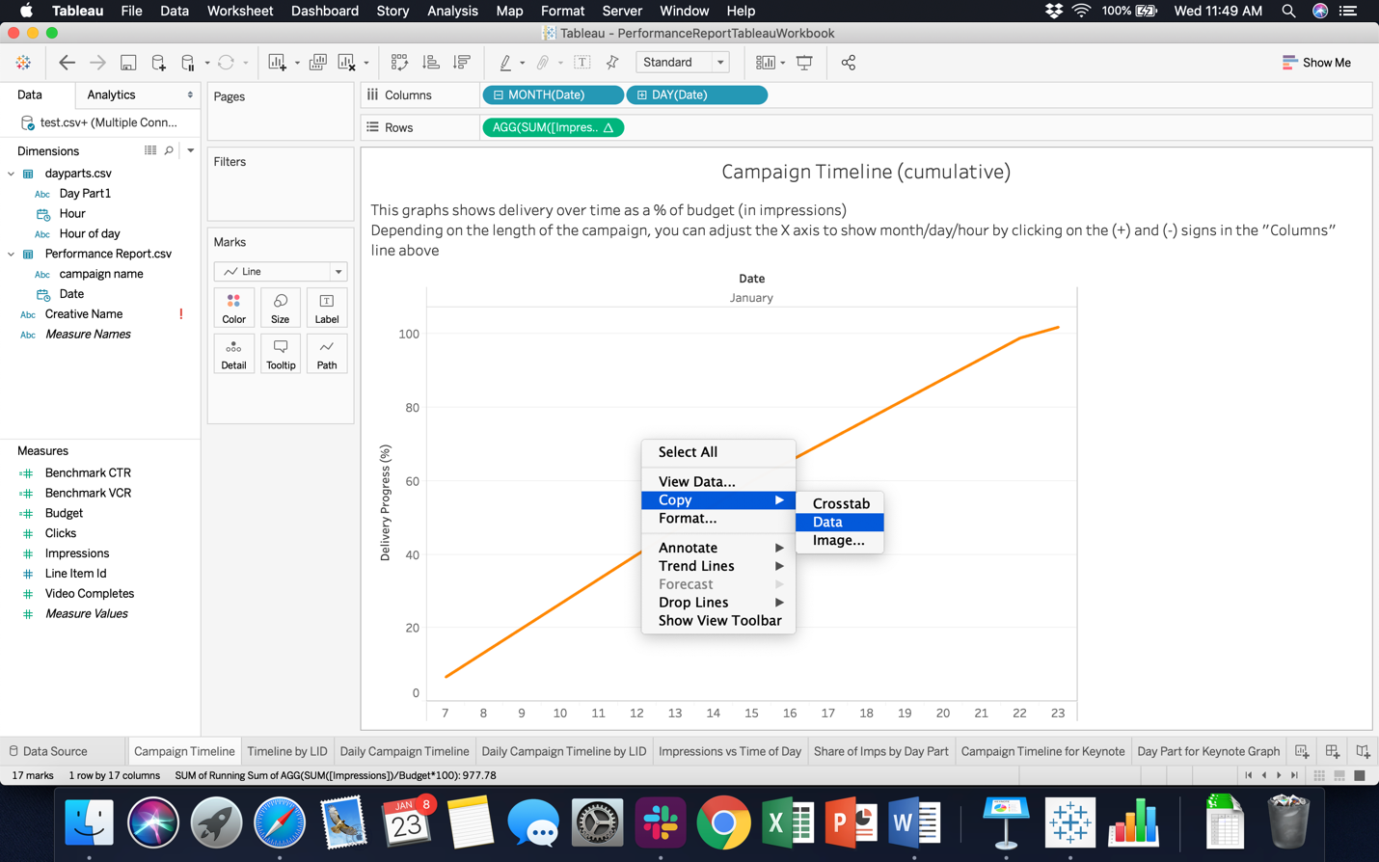

**Worksheet 5: “Campaign by LID”**

The graph here is the same as on the previous slide, but broken down into Line Items. You can filter the line items in in the right pane by selecting the ones you want to display.

**Worksheet 6: “Daily Campaign Timeline”**

The graph shows the number of impressions per day/month/hour (depending on how you adjust the X-axis).

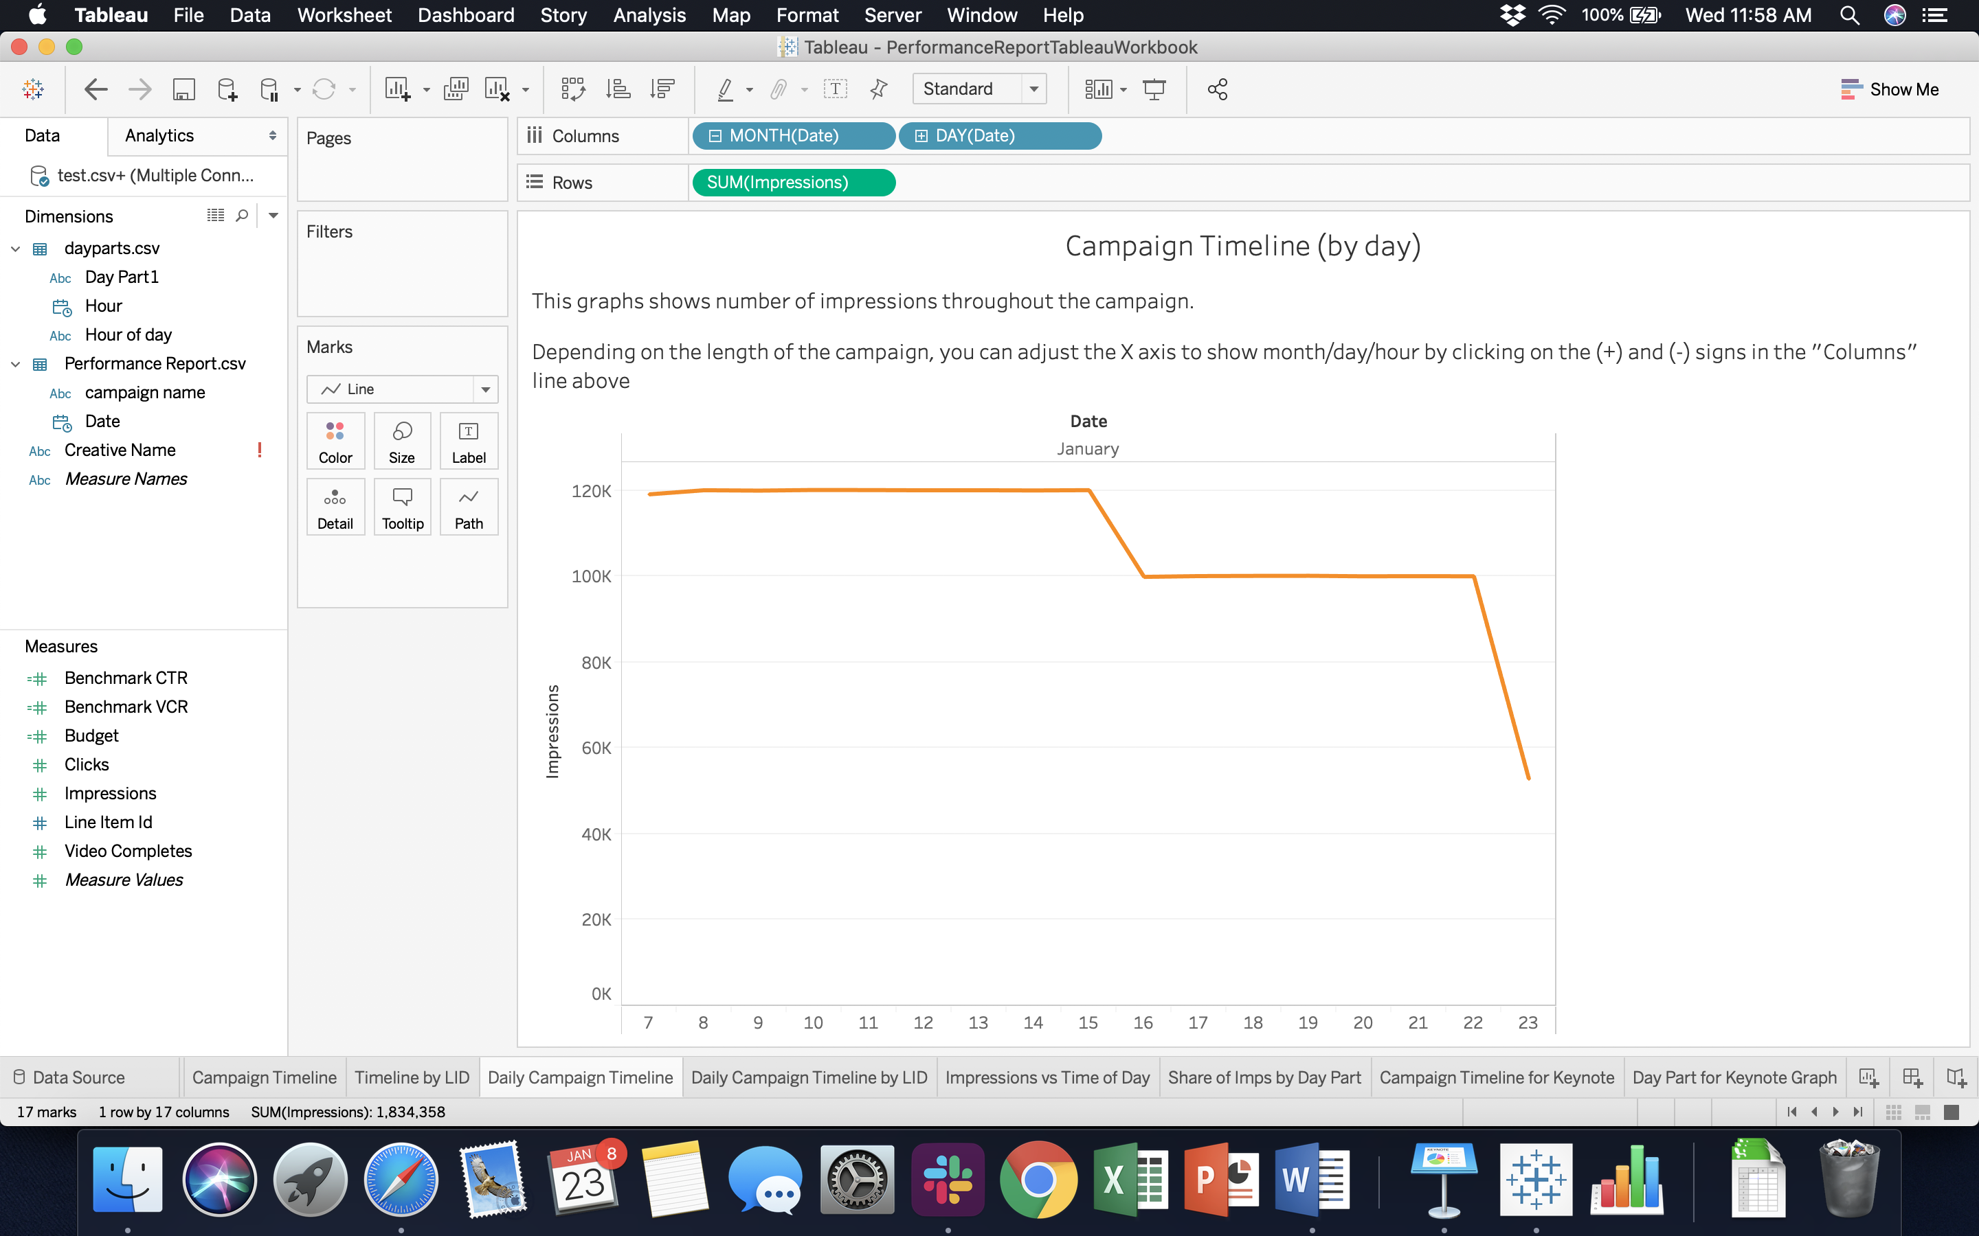

**Worksheet 7: “Daily Campaign Timeline by LID”**

Same as above but broken down by LID. You can filter the LIDs you want displayed and adjust the X axis.

**Worksheet 8: “Impressions vs Time of Day”**

This plots the average number of impressions as a function of the time of day. You can use this graph to generate the slide “Digital Campaign Delivery by Day Part” in a Digital Campaign Performance Study.

To copy the chart, either take a screen shot of it or copy the data (right click > copy > data) and paste it in the Keynote (edit chart data then paste). WARNING: you may have to rearrange the lines (i.e. order the hours) if you choose this option.

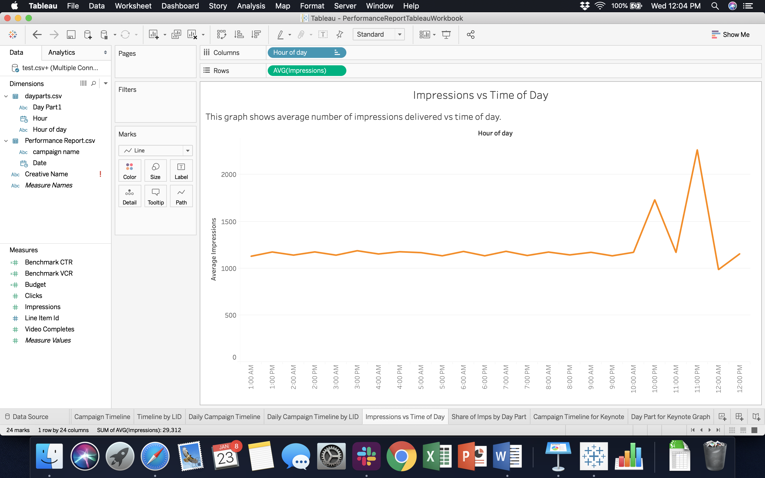

**Worksheet 9: “Share of Imps by Day Part”**

This pie chart specifies the breakdown of impressions by day parts. It can be used to generate the slide “Digital Campaign Delivery by Day Part” (by taking a screen shot)

**Worksheets 10 & 11: “Campaign Timeline for Keynote Graph Generation” and “Day Part for Keynote Graph Generation”.**

Both of those worksheet are tables you can copy to generate graphs on Keynote (instead of taking screen shots”.

The first one can be copied to generate the “Campaign Delivery Progress” slide in a report.

The second one can be copied to generate the pie chart of impressions vs Day Part.

**Generate and import your Geographic data to the Tableau Geo Report Workbook**

Log in to Beeswax

In the Reporting tab, go to the Query tool.

Fill in the following fields:

* Report type: Geography
* Fields:
  + Country
  + City
  + Metro/DMA
  + Metro/DMA code
  + Region/State

Metrics

* + Clicks
  + Impressions
  + Video Completes
* Select your campaign in Campaign Name or Campaign ID field
* Format: CSV
* Report name: Geo Report

Run and Download the report

**Rename it Geo Report.csv**

Place it in the Dropbox in the following location: *Alphonso Campaign Reporting > Elle & Gaelle* **(replace the previous file with the same name)**

Get the Geography Report Tableau WorkBook [here](Geo%20Report%20Workbook.twbx) (or from dropbox in *Alphonso Campaign Reporting > Elle & Gaelle*)

Open the Tableau Workbook

Click on the tab Data Source (see screenshot below)

In the upper left corner, refresh the connections by clicking on

The data should refresh and correspond to the report you just generated. If that is not the case try the steps mentioned in the previous section to fix this.

You have now imported your report to the notebook and the maps and tables should correspond to your campaign. The different sheets in the Workbook are explained in the section “Navigating and using the workbook”.

**Navigating and using the workbook**

The workbook contains various maps showing number of impressions and completion rate over cities, states and DMAs. The worksheets at the end of the book provide you with tables, sorted in decreasing number of impressions and completion rate. Those tables can help you generate Campaign reports.

A few things to take into account when generating maps:

* Tableau does not have access to Longitude and Latitude for all of the cities, the map will by cities will not contain every city in your campaign
* Every DMA is matched to a longitude/latitude/code and every city is matched to a DMA so DMA map is accurate

